IBM NaanMuthalvan – Artificial Inteligence Group 4

College name : SSM Institute Of Engineering And

Technology.

College code : 9221

Team Members :

J.Margrate Sneka (922121106045)

S.Nagapriya (922121106056)

M.Pooja (922121106064)

C.M.Priyadharshini (922121106069)

Phase 2:

MEASURE ENERGY CONSUMPTION

Process:

Step1:

Gather the necessary data

Step2:

This typically involves collecting energy consumption data from various sources

Step3:

Clean and preprocess the data to remove outliers, handle missing values, and format it for analysis

Step4:

Create relevant features from the data, such as time of day, weather conditions, or occupancy patterns, which could impact energy consumption

Step5:

Choose the appropriate AI techniques for our project

Step6:

Train our AI models using the preprocessed data

Step7:

Implement anomaly detection algorithms to identify irregular or inefficient energy consumption patterns.

Step8:

Develop visualization tools to present the results

Step9:

Consider how our project can be scaled to accommodate more extensive energy monitoring, if needed

Python Coding:

import random

import time

from datetime import datetime

# Simulated energy consumption data generator

def generate_energy_data():

current_time = datetime.now()

while True:

timestamp = current_time.strftime("%Y-%m-%d %H:%M:%S")

energy_consumption = random.uniform(100, 1000) # Simulated consumption in watts

yield timestamp, energy_consumption

time.sleep(1) # Simulate data update every second

# Data storage (you can use a database or file storage in a real system)

def store_energy_data(timestamp, energy_consumption):

with open('energy_data.csv', 'a') as f:

f.write(f'{timestamp},{energy_consumption}\n')

if __name__ == "__main__":

data_generator = generate_energy_data()

try:

while True:

timestamp, energy_consumption = next(data_generator)

store_energy_data(timestamp, energy_consumption)

print(f"Timestamp: {timestamp}, Energy Consumption: {energy_consumption} W")

except KeyboardInterrupt:

print("Monitoring stopped.")

Energy monitor:

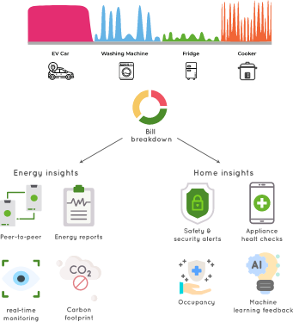

Solution:

* Smart meters with built-in AI algorithms can continuously collect and analyze energy consumption data at a granular level, often in real-time
* Machine learning models can identify patterns, anomalies, and trends in energy consumption
* AI can forecast future energy consumption based on historical data and external factors like weather forecasts
* Some devices can be integrated with smart home or building systems to remotely control appliances, thermostats, lighting, and other devices to optimize energy usage
* Many of these devices have companion apps that provide users with easy access to energy consumption data and insights on their mobile devices
* This information can motivate users to reduce their environmental impact

Conclusion:

Incorporating AI into energy consumption management provides a pathway to reducing energy costs, minimizing environmental impact, and promoting sustainability. It empowers individuals, businesses, and utilities to make data-driven decisions, ultimately contributing to more efficient and responsible energy use. Regular updates and maintenance are crucial to keep AI algorithms accurate and relevant.